Assignment 2 :

1. Draw a labeled diagram of an ATX motherboard and mark at least 8 different slots and ports (such as RAM slots, PCIe slots, SATA ports, USB headers, CPU socket, power connector, etc.).

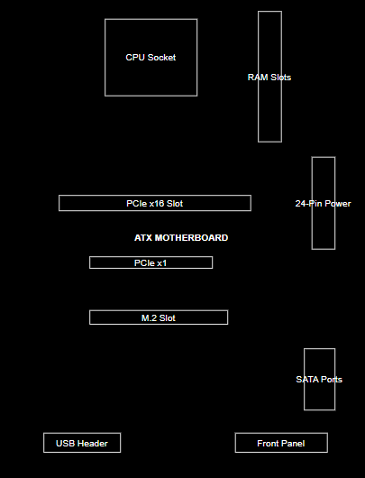

Q2: Research and list 3 popular CPU socket types (for example: LGA1151, AM4, LGA1200) and name one compatible CPU model for each.

Cpu socket type compatible cpu model
LGA1151 - intel(6th and 7th gen) → Intel Core i7-7700K
AM4- AMD (ryzen 1000 to 5000 series) → AMD Ryzen 5 3600
LGA1200 - intel(10th and 11th gen) → Intel Core i5-10400

Q.3 Explain in your own words the primary functions of the CPU and the chipset on a motherboard, and describe how they work together when you open a music app like Spotify.

CPU (Central Processing Unit):
The CPU is the brain of the computer. Its main job is to process instructions, perform calculations, and run programs.
Chipset:
The chipset is a part of the motherboard that helps the CPU communicate with other hardware like RAM, storage (SSD/HDD), USB ports, and other devices.
How They Work Together When You Open Spotify:
When you open Spotify, the CPU processes your command to start the app. The chipset helps move the app's data from the SSD or HDD to the RAM and allows the CPU to communicate with other components. Together, the CPU and chipset make sure Spotify opens and plays music smoothly.

Q4: Find a clear photo of a real motherboard (from the internet or your own device), and identify at least 5 different ports or slots by circling them and labeling each one.

